Performance Test on D230E

This document aims to report the performance of D230E work with multiple channels concurrent calls on the E-MetroTel.

**Test environments:**

**Server A:**

CentOS release 5.10 (Final)

Kernel version: 2.6.18-371.4.1.el5

asterisk 1.8.25.0

dahdi-linux-complete-2.6.1+2.6.1

libpri-1.4.14

OpenVox D230E

CPU: Intel(R) Atom(TM) CPU N2600 @ 1.60GHz

Memory: 1024MB

**Server B:**

CentOS release 5.9 (Final)

Kernel version: 2.6.18-348.el5

asterisk-11.7.0

dahdi-linux-complete-2.9.0+2.9.0.1

libpri-1.4.14

OpenVox D210P

CPU: Pentium(R) Dual-Core CPU E5300 @ 2.60GHz

Memory: 1024MB

Contents

Test environments…………………………………………………………………1

Contents……………………………………………………………………………2

Connection…………………………………………………………………………3

Chapter 1 Installation………………………………………………………………4

1.1 Hardware detection…………………………………………………………..4

1.2 Check and install the dependency package………………………………….4

1.3 Install Libpri, Dahdi and Asterisk…………………………………..……….4

1.4 Load the driver and configure……………………………………………….4

1.5 Load the configuration files, start asterisk…………………………………..7

Chapter 2 Test………………………………………………………………….….10

2.1 Test…………………………………………………………………………..10

2.2 The CPU Usage……………………………………………………………...12

Connection:

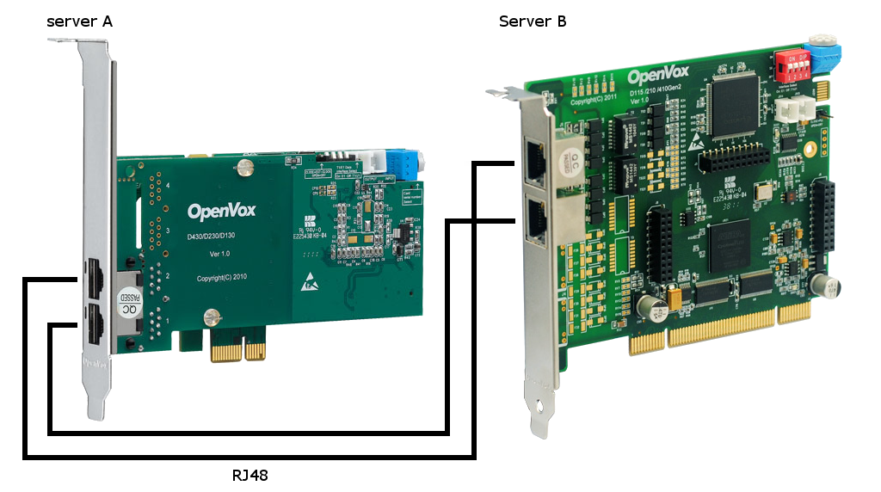

Figure 1

Chapter 1 Installation

* 1. **Hardware detection**

Please run the command as below to check the outcome and confirm your system has recognized D230E:

[root@ucx20 ~]# lspci –v

If it has been recognized, it will be displayed in the output information like that:

*03:00.0 Network controller: Digium, Inc. Wildcard TE220 dual-span T1/E1/J1 card 3.3V (PCI-Express) (5th gen) (rev 15)*

*Subsystem: Device 0005:0000*

*Flags: bus master, slow devsel, latency 32, IRQ 177*

*Memory at dfd00000 (32-bit, non-prefetchable) [size=32K]*

*Kernel modules: wct4xxp*

Figure 2

If D230E is not recognized by the system, you have to power off and take out the card, then try to insert it into other PCI-E slot.

* 1. **Check and install the dependency package**

Some dependencies are crucial. If any of them is absent, the software installation process would not go through successfully. Please run “yum install XXX”(XXX stands for the dependency’s name) to check the availability of dependencied.

# yum install bison

# yum install bison-devel

# yum install ncurses

# yum install ncurses-devel

# yum install zlib

# yum install zlib-devel

# yum install openssl

# yum install openssl-devel

# yum install gnutls-devel

# yum install gcc

# yum install gcc-c++

# yum install libxml2

# yum install libxml2-devel

If there is no kernel-devel source in the system, you should run the following command to install the kernel-devel to match current kernel

# yum install kernel-devel-`uname –r`

If there is no matched kernel-devel found, you should download matched RPM package to install it, or execute the following command to update to the latest kernel version:

# yum install kernel kernel-devel

After installed, please reboot your machine to apply the new kernel and install the dependencies. If the dependency has been installed, system indicates that nothing to do which means you could go to next one directly. Otherwise, the system will keep on installing it.

* 1. **Install Libpri, Dahdi and Asterisk**

Copy the file of libpri, dahdi, and asterisk to /usr/src directory and decompress.

[root@ucx20 ~]# tar -zxvf libpri-1.4.12.tar.gz

[root@ucx20 ~]# tar -zxvf openvox_dahdi-linux-complete-2.2.1+2.2.1.tar.gz

[root@ucx20 ~]# tar -zxvf asterisk-1.4.25.tar.gz

Install the libpri, dahdi and asterisk:

Libpri: make clean && make && make install

Dahdi: make clean && make && make install && make config

Asterisk: make clean && ./configure && make && make install && make samples

* 1. **Load the driver and configure**

Driver loading

Please load the driver by running:

[root@ucx20 ~]# modprobe dahdi

[root@ucx20 ~]# modprobe wct4xxp

[root@ucx20 ~]# dahdi_genconf

Edit the configuration file:

[root@ucx20 ~]# vim /etc/dahdi/system.conf

*# Autogenerated by /usr/sbin/dahdi_genconf on Thu Apr 17 22:46:35 2014*

*# If you edit this file and execute /usr/sbin/dahdi_genconf again,*

*# your manual changes will be LOST.*

*# Dahdi Configuration File*

*#*

*# This file is parsed by the Dahdi Configurator, dahdi_cfg*

*#*

*# Span 1: TE2/0/1 "T2XXP (PCI) Card 0 Span 1" (MASTER)*

*span=1,1,0,ccs,hdb3,crc4*

*# termtype: te*

*bchan=1-15,17-31*

*dchan=16*

*echocanceller=oslec,1-15,17-31*

*# Span 2: TE2/0/2 "T2XXP (PCI) Card 0 Span 2"*

*span=2,2,0,ccs,hdb3,crc4*

*# termtype: te*

*bchan=32-46,48-62*

*dchan=47*

*echocanceller=oslec,32-46,48-62*

*# Global data*

*loadzone = cn*

*defaultzone = cn*

Figure 3

[root@ucx20 ~]# vim /etc/asterisk/dahdi-channels.conf

*; Autogenerated by /usr/sbin/dahdi_genconf on Thu Apr 17 22:46:35 2014*

*; If you edit this file and execute /usr/sbin/dahdi_genconf again,*

*; your manual changes will be LOST.*

*; Dahdi Channels Configurations (chan_dahdi.conf)*

*;*

*; This is not intended to be a complete chan_dahdi.conf. Rather, it is intended*

*; to be #include-d by /etc/chan_dahdi.conf that will include the global settings*

*;*

*; Span 1: TE2/0/1 "T2XXP (PCI) Card 0 Span 1" (MASTER)*

*group=1,11*

*context=from-internal*

*switchtype = euroisdn*

*signalling = pri_net*

*channel => 1-15,17-31*

*context = default*

*group = 63*

*; Span 2: TE2/0/2 "T2XXP (PCI) Card 0 Span 2"*

*group=1,12*

*context=from-pstn*

*switchtype = euroisdn*

*signalling = pri_cpe*

*channel => 32-46,48-62*

*context = default*

*group = 63*

Figure 4

[root@ucx20 ~]# vim /etc/asterisk/chan_dahdi.conf

; Add this line at the end of file chan_dahdi.conf

#include "/etc/asterisk/dahdi-channels.conf"

[root@ucx20 ~]# vim /etc/asterisk/indications.conf

*country=cn ; default location*

[root@ucx20 ~]# vim /etc/asterisk/sip.conf

*; Add these section*

*[36001]*

*type=friend*

*username=36001*

*secret=36001*

*context=from-internal*

*host=dynamic*

*……*

*[36060]*

*type=friend*

*username=36060*

*secret=36060*

*host=dynamic*

*context=from-internal*

Figure 5

[root@ucx20 ~]# vim /etc/asterisk/extensions.conf

*[from-pstn]*

*exten => s,1,Answer()*

*exten => s,n,Playback(demo-instruct)*

*exten => s,n,Hangup()*

*[from-internal]*

*exten => _X.,1,Answer()*

*exten => _X.,n,Dial(dahdi/g1)*

*exten => _X.,n,Hangup()*

Figure 6

* 1. **Load the configuration files, start asterisk**

Please execute the following command to read and load parameters in the configuration file system.conf and writing to the hardware:

[root@ucx20 ~]# dahdi_cfg -vvv

*DAHDI Tools Version - 2.6.1*

*DAHDI Version: 2.6.1*

*Echo Canceller(s): HWEC, OSLEC*

*Configuration*

*======================*

*SPAN 1: CCS/HDB3 Build-out: 0 db (CSU)/0-133 feet (DSX-1)*

*SPAN 2: CCS/HDB3 Build-out: 0 db (CSU)/0-133 feet (DSX-1)*

*Channel map:*

*Channel 01: Clear channel (Default) (Echo Canceler: oslec) (Slaves: 01)*

*Channel 02: Clear channel (Default) (Echo Canceler: oslec) (Slaves: 02)*

*Channel 03: Clear channel (Default) (Echo Canceler: oslec) (Slaves: 03)*

*Channel 04: Clear channel (Default) (Echo Canceler: oslec) (Slaves: 04)*

*Channel 05: Clear channel (Default) (Echo Canceler: oslec) (Slaves: 05)*

*Channel 06: Clear channel (Default) (Echo Canceler: oslec) (Slaves: 06)*

*Channel 07: Clear channel (Default) (Echo Canceler: oslec) (Slaves: 07)*

*Channel 08: Clear channel (Default) (Echo Canceler: oslec) (Slaves: 08)*

*Channel 09: Clear channel (Default) (Echo Canceler: oslec) (Slaves: 09)*

*Channel 10: Clear channel (Default) (Echo Canceler: oslec) (Slaves: 10)*

*Channel 11: Clear channel (Default) (Echo Canceler: oslec) (Slaves: 11)*

*Channel 12: Clear channel (Default) (Echo Canceler: oslec) (Slaves: 12)*

*Channel 13: Clear channel (Default) (Echo Canceler: oslec) (Slaves: 13)*

*Channel 14: Clear channel (Default) (Echo Canceler: oslec) (Slaves: 14)*

*Channel 15: Clear channel (Default) (Echo Canceler: oslec) (Slaves: 15)*

*Channel 16: D-channel (Default) (Echo Canceler: none) (Slaves: 16)*

*Channel 17: Clear channel (Default) (Echo Canceler: oslec) (Slaves: 17)*

*Channel 18: Clear channel (Default) (Echo Canceler: oslec) (Slaves: 18)*

*Channel 19: Clear channel (Default) (Echo Canceler: oslec) (Slaves: 19)*

*Channel 20: Clear channel (Default) (Echo Canceler: oslec) (Slaves: 20)*

*Channel 21: Clear channel (Default) (Echo Canceler: oslec) (Slaves: 21)*

*Channel 22: Clear channel (Default) (Echo Canceler: oslec) (Slaves: 22)*

*Channel 23: Clear channel (Default) (Echo Canceler: oslec) (Slaves: 23)*

*Channel 24: Clear channel (Default) (Echo Canceler: oslec) (Slaves: 24)*

*Channel 25: Clear channel (Default) (Echo Canceler: oslec) (Slaves: 25)*

*Channel 26: Clear channel (Default) (Echo Canceler: oslec) (Slaves: 26)*

*Channel 27: Clear channel (Default) (Echo Canceler: oslec) (Slaves: 27)*

*Channel 28: Clear channel (Default) (Echo Canceler: oslec) (Slaves: 28)*

*Channel 29: Clear channel (Default) (Echo Canceler: oslec) (Slaves: 29)*

*Channel 30: Clear channel (Default) (Echo Canceler: oslec) (Slaves: 30)*

*Channel 31: Clear channel (Default) (Echo Canceler: oslec) (Slaves: 31)*

*Channel 32: Clear channel (Default) (Echo Canceler: oslec) (Slaves: 32)*

*Channel 33: Clear channel (Default) (Echo Canceler: oslec) (Slaves: 33)*

*Channel 34: Clear channel (Default) (Echo Canceler: oslec) (Slaves: 34)*

*Channel 35: Clear channel (Default) (Echo Canceler: oslec) (Slaves: 35)*

*Channel 36: Clear channel (Default) (Echo Canceler: oslec) (Slaves: 36)*

*Channel 37: Clear channel (Default) (Echo Canceler: oslec) (Slaves: 37)*

*Channel 38: Clear channel (Default) (Echo Canceler: oslec) (Slaves: 38)*

*Channel 39: Clear channel (Default) (Echo Canceler: oslec) (Slaves: 39)*

*Channel 40: Clear channel (Default) (Echo Canceler: oslec) (Slaves: 40)*

*Channel 41: Clear channel (Default) (Echo Canceler: oslec) (Slaves: 41)*

*Channel 42: Clear channel (Default) (Echo Canceler: oslec) (Slaves: 42)*

*Channel 43: Clear channel (Default) (Echo Canceler: oslec) (Slaves: 43)*

*Channel 44: Clear channel (Default) (Echo Canceler: oslec) (Slaves: 44)*

*Channel 45: Clear channel (Default) (Echo Canceler: oslec) (Slaves: 45)*

*Channel 46: Clear channel (Default) (Echo Canceler: oslec) (Slaves: 46)*

*Channel 47: D-channel (Default) (Echo Canceler: none) (Slaves: 47)*

*Channel 48: Clear channel (Default) (Echo Canceler: oslec) (Slaves: 48)*

*Channel 49: Clear channel (Default) (Echo Canceler: oslec) (Slaves: 49)*

*Channel 50: Clear channel (Default) (Echo Canceler: oslec) (Slaves: 50)*

*Channel 51: Clear channel (Default) (Echo Canceler: oslec) (Slaves: 51)*

*Channel 52: Clear channel (Default) (Echo Canceler: oslec) (Slaves: 52)*

*Channel 53: Clear channel (Default) (Echo Canceler: oslec) (Slaves: 53)*

*Channel 54: Clear channel (Default) (Echo Canceler: oslec) (Slaves: 54)*

*Channel 55: Clear channel (Default) (Echo Canceler: oslec) (Slaves: 55)*

*Channel 56: Clear channel (Default) (Echo Canceler: oslec) (Slaves: 56)*

*Channel 57: Clear channel (Default) (Echo Canceler: oslec) (Slaves: 57)*

*Channel 58: Clear channel (Default) (Echo Canceler: oslec) (Slaves: 58)*

*Channel 59: Clear channel (Default) (Echo Canceler: oslec) (Slaves: 59)*

*Channel 60: Clear channel (Default) (Echo Canceler: oslec) (Slaves: 60)*

*Channel 61: Clear channel (Default) (Echo Canceler: oslec) (Slaves: 61)*

*Channel 62: Clear channel (Default) (Echo Canceler: oslec) (Slaves: 62)*

*62 channels to configure.*

*Setting echocan for channel 1 to oslec*

*Setting echocan for channel 2 to oslec*

*Setting echocan for channel 3 to oslec*

*Setting echocan for channel 4 to oslec*

*Setting echocan for channel 5 to oslec*

*Setting echocan for channel 6 to oslec*

*Setting echocan for channel 7 to oslec*

*Setting echocan for channel 8 to oslec*

*Setting echocan for channel 9 to oslec*

*Setting echocan for channel 10 to oslec*

*Setting echocan for channel 11 to oslec*

*Setting echocan for channel 12 to oslec*

*Setting echocan for channel 13 to oslec*

*Setting echocan for channel 14 to oslec*

*Setting echocan for channel 15 to oslec*

*Setting echocan for channel 16 to none*

*Setting echocan for channel 17 to oslec*

*Setting echocan for channel 18 to oslec*

*Setting echocan for channel 19 to oslec*

*Setting echocan for channel 20 to oslec*

*Setting echocan for channel 21 to oslec*

*Setting echocan for channel 22 to oslec*

*Setting echocan for channel 23 to oslec*

*Setting echocan for channel 24 to oslec*

*Setting echocan for channel 25 to oslec*

*Setting echocan for channel 26 to oslec*

*Setting echocan for channel 27 to oslec*

*Setting echocan for channel 28 to oslec*

*Setting echocan for channel 29 to oslec*

*Setting echocan for channel 30 to oslec*

*Setting echocan for channel 31 to oslec*

*Setting echocan for channel 32 to oslec*

*Setting echocan for channel 33 to oslec*

*Setting echocan for channel 34 to oslec*

*Setting echocan for channel 35 to oslec*

*Setting echocan for channel 36 to oslec*

*Setting echocan for channel 37 to oslec*

*Setting echocan for channel 38 to oslec*

*Setting echocan for channel 39 to oslec*

*Setting echocan for channel 40 to oslec*

*Setting echocan for channel 41 to oslec*

*Setting echocan for channel 42 to oslec*

*Setting echocan for channel 43 to oslec*

*Setting echocan for channel 44 to oslec*

*Setting echocan for channel 45 to oslec*

*Setting echocan for channel 46 to oslec*

*Setting echocan for channel 47 to none*

*Setting echocan for channel 48 to oslec*

*Setting echocan for channel 49 to oslec*

*Setting echocan for channel 50 to oslec*

*Setting echocan for channel 51 to oslec*

*Setting echocan for channel 52 to oslec*

*Setting echocan for channel 53 to oslec*

*Setting echocan for channel 54 to oslec*

*Setting echocan for channel 55 to oslec*

*Setting echocan for channel 56 to oslec*

*Setting echocan for channel 57 to oslec*

*Setting echocan for channel 58 to oslec*

*Setting echocan for channel 59 to oslec*

*Setting echocan for channel 60 to oslec*

*Setting echocan for channel 61 to oslec*

*Setting echocan for channel 62 to oslec*

Figure 7

Start asterisk:

[root@ucx20 ~]# asterisk –vvvvvvgc

If asterisk is already activate, please run “asterisk -r” instead.

If the card has been correct install, please connect the server A’s port 1 to the server B’s port 2, and connect the server A’s port 2 to the server B’s port 1, then run “pri show spans” in the CLI:

*\*CLI> pri show spans*

*PRI span 1/0: Up, Active*

*PRI span 2/0: Up, Active*

*\*CLI>*

Figure 8

Chapter 2 Test

**2.1 Test**

Use WinSIP to test 60 channels concurrent calls with D230E on the E-MetroTel:

*localhost*CLI> core show channels*

*Channel Location State Application(Data)*

*DAHDI/i2/36003-124 s@from-pstn:2 Up Playback(demo-instruct)*

*DAHDI/i2/36009-12a s@from-pstn:2 Up Playback(demo-instruct)*

*DAHDI/i2/36025-13a s@from-pstn:2 Up Playback(demo-instruct)*

*DAHDI/i1/36034-ca s@from-pstn:2 Up Playback(demo-instruct)*

*DAHDI/i2/36019-134 s@from-pstn:2 Up Playback(demo-instruct)*

*…...*

*DAHDI/i1/36053-d7 s@from-pstn:2 Up Playback(demo-instruct)*

*DAHDI/i2/36020-135 s@from-pstn:2 Up Playback(demo-instruct)*

*DAHDI/i2/36016-131 s@from-pstn:2 Up Playback(demo-instruct)*

*DAHDI/i1/36041-cb s@from-pstn:2 Up Playback(demo-instruct)*

*50 active channels*

*50 active calls*

*534 calls processed*

Figure 9

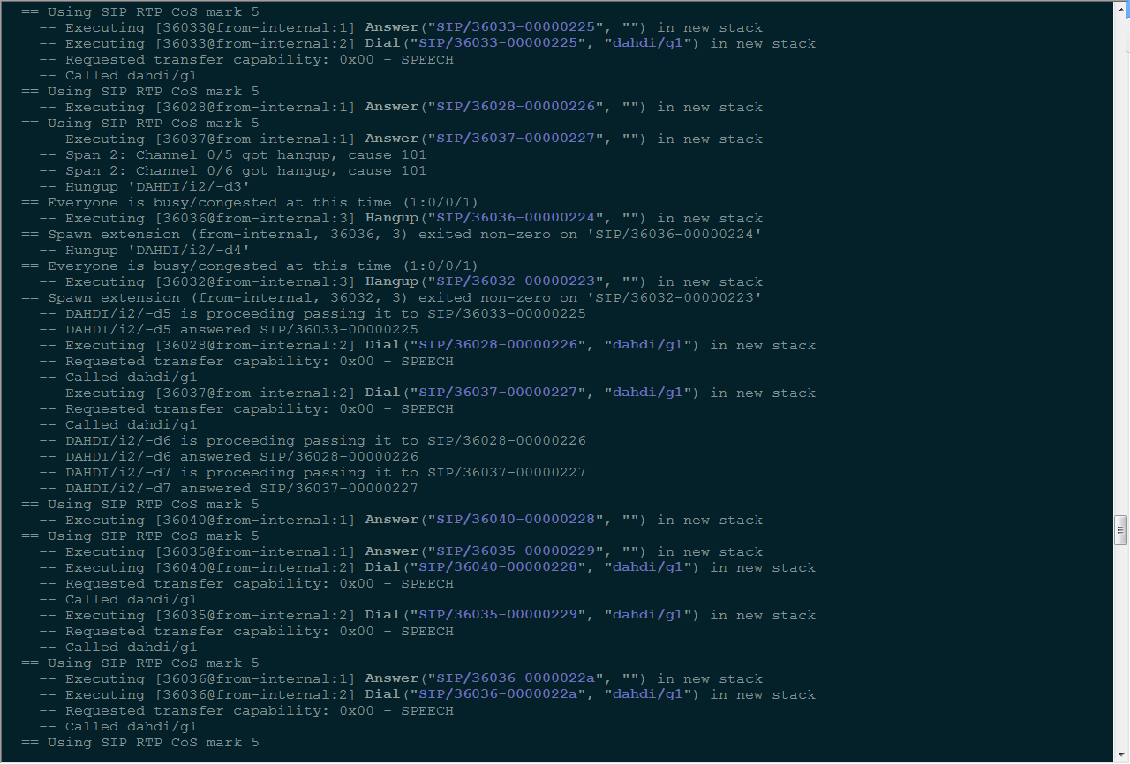

Figure 10

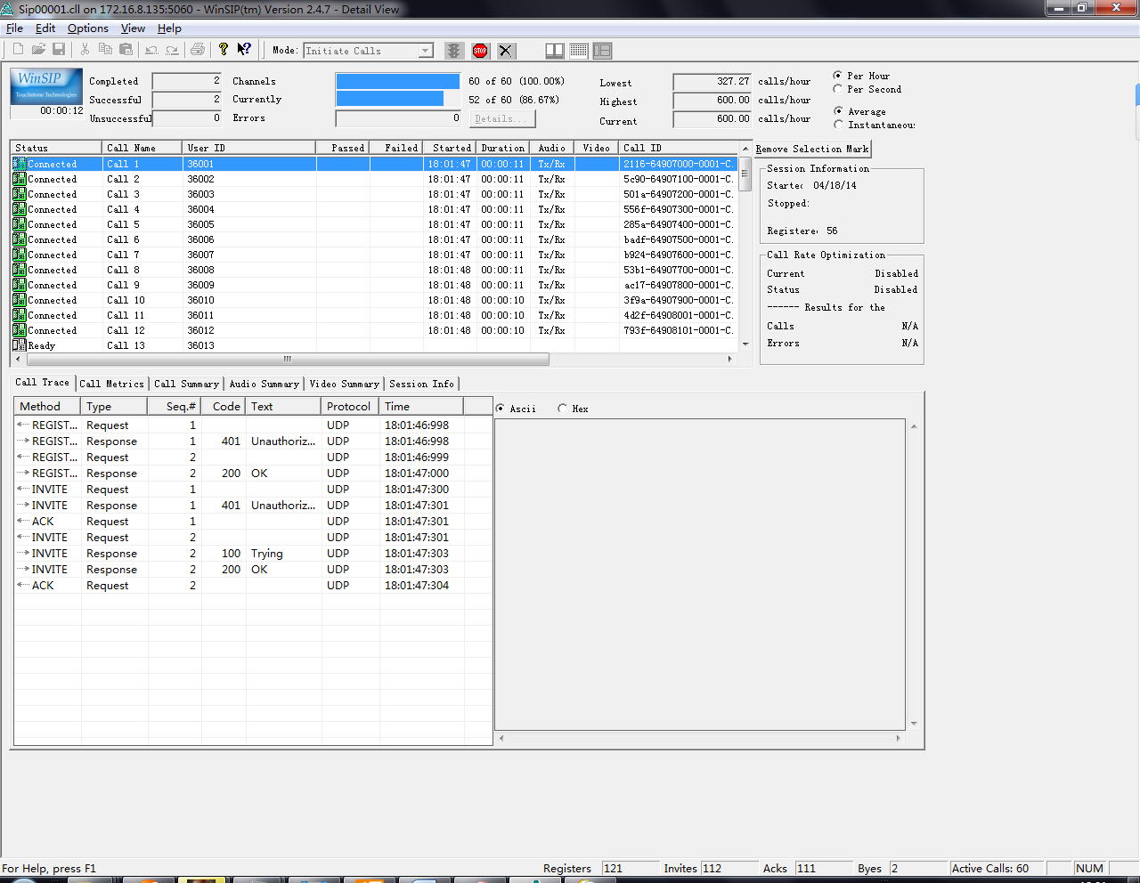

Figure 11

**2.2 The CPU Useage**

When test test 60 channels concurrent calls, the CPU Useage of the E-MetroTel is 47.7%, sometimes reach up to 57%:

